**Performance Test Report**

**For**

**Execution of**

**Registration-Processor Packet Upload – 100 packets**

Date: 13 November 2019

Author: Gaurav Sharan

**Summary**

This report presents the observations and findings of the load test conducted for uploading and processing 100 packets in registration processor module.

The objective of this load test was to observe and record the behavior of the application when 20 concurrent users upload 5 packets each to the registration processor packet receiver component.

Below are the scenario details:

|  |  |
| --- | --- |
| **Sprint/Report Name** | Reg-Processor Packet Upload |
| **Run Date** | 13-November-2019 |
| **Period (Accessing Packet Upload APIs)** | 06:39:02 AM to 06:44:20 AM (UTC) |
| **Period (Packet processing)** | 06:39:02 AM to 10:52:40.063 AM (UTC) |
| **Number of concurrent users** | 20 |
| **Ramp up** | 40 seconds |
| **Run Duration** | NA |
| **Ramp down** | NA |

The transaction response times observed were as below:

|  |  |  |  |  |  |  |  |
| --- | --- | --- | --- | --- | --- | --- | --- |
| **Label** | **# Samples** | **Average(ms)** | **90% Line(ms)** | **Min(ms)** | **Max(ms)** | **Error %** | **Throughput** |
| **TR_regproc_authentication** | 100 | 226 | 502 | 36 | 1413 | 0.00% | 0.38126 |
| **TR_regproc_encrypt** | 100 | 28 | 36 | 22 | 58 | 0.00% | 0.38254 |
| **TR_regproc_sync_reg_packets** | 100 | **14348** | **28839** | 822 | 33767 | 0.00% | 0.3477 |
| **TR_regproc_upload_registration_packet** | 100 | **11733** | **21342** | 509 | 30005 | 0.00% | 0.3298 |
| **TR_regproc_check_packet_upload_status** | 100 | **4341** | **7745** | 196 | 17197 | 0.00% | 0.32688 |
| **TR_regproc_authentication** | 100 | 226 | 502 | 36 | 1413 | 0.00% | 0.38126 |

**Performance Test Execution Details**

We have executed the packet upload flow, which has transactions mentioned in the above table.

Response times for most of the transactions started exceeding the SLA (3 sec) after certain duration of time

After the ramp up of users gets stable, average response time for critical transactions like sync and packet upload can be seen in the response times over time graph as more than 5 seconds.

Below listed transactions are the highest time taking:

1. TR_regproc_upload_registration_packet (11.7 sec)
2. TR_regproc_sync_reg_packets (14.3 sec)

**Active Threads Over Time**

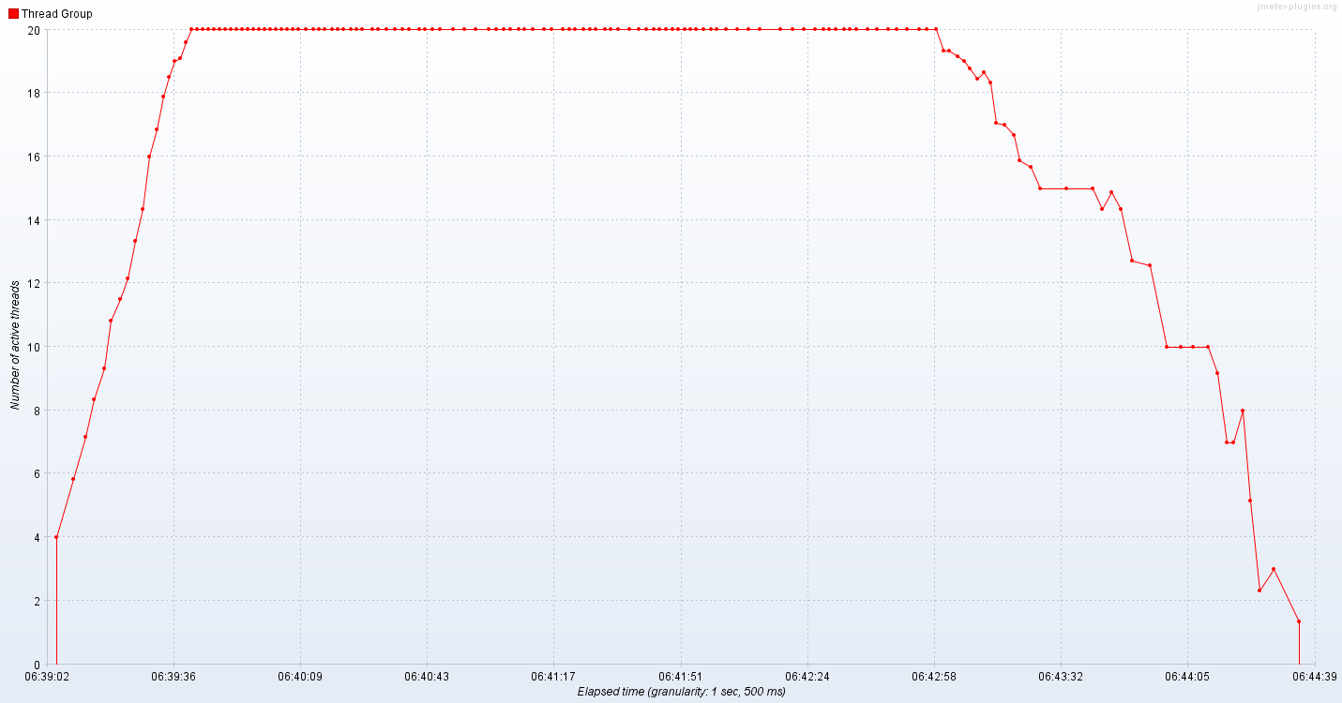

As seen in the above graph, 20 users were active for around 3 minutes.

**Response Time Graph**

Most of the transactions have response time above the SLA (3 sec). Response time has raised high with arrival of users.

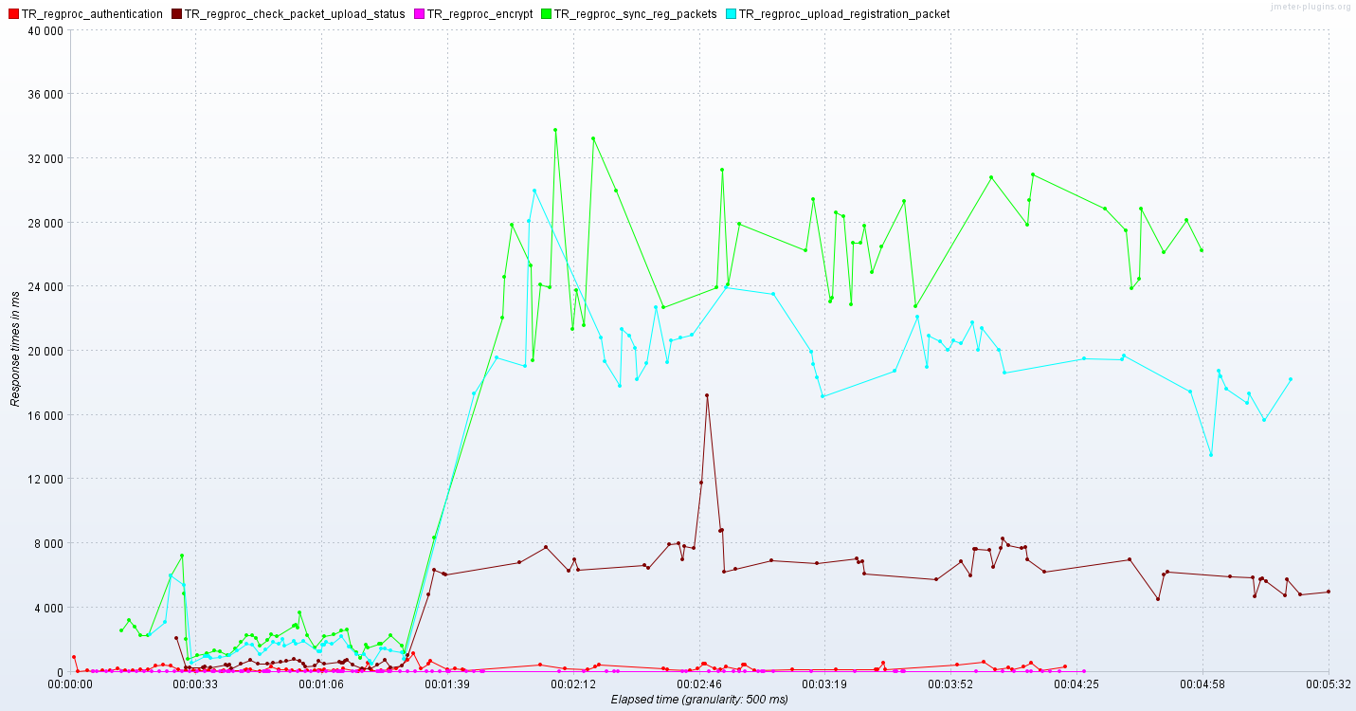

**Packet Processing Times**

Attached excel sheet mentions the time spent packet wise in each stage. Total time taken to process a packet is mentioned in the last row of each column.



**Resource Monitoring**

Kubernetes nodes were monitored using Prometheus and Grafana from 13th November 06:00 UTC - 13:00 UTC

***aks-agentpool-32091406-0 (VM 1)***

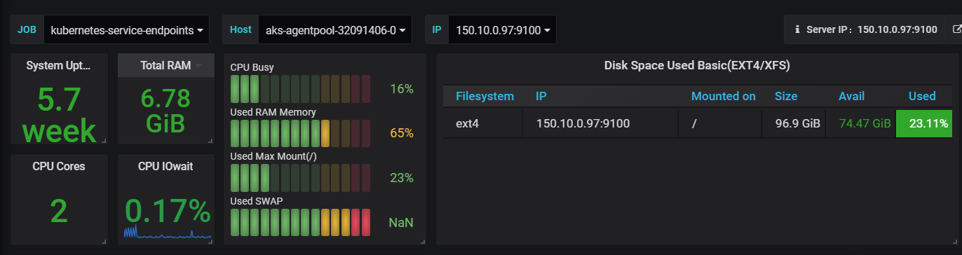

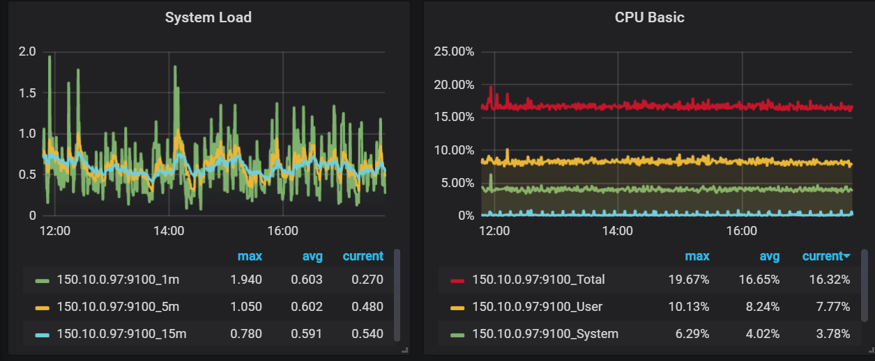

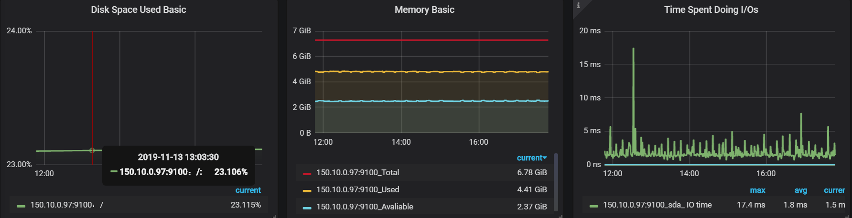

***aks-agentpool-32091406-1 (VM 2):***

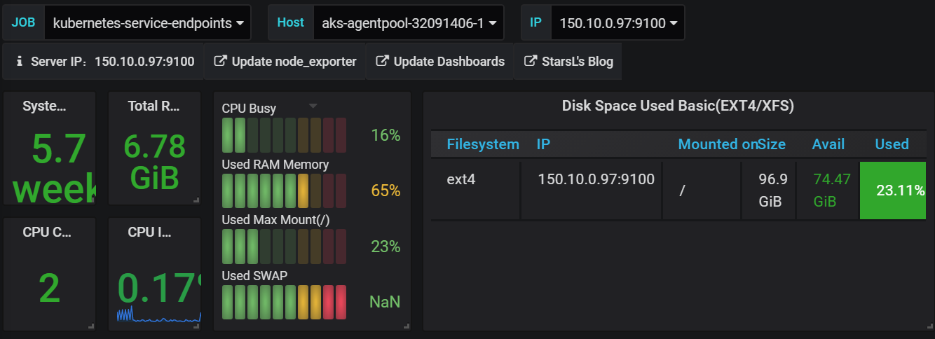

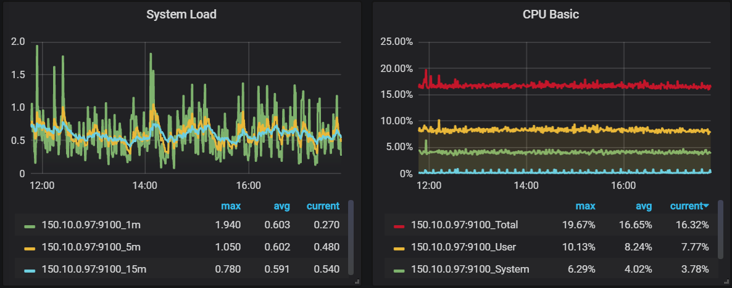

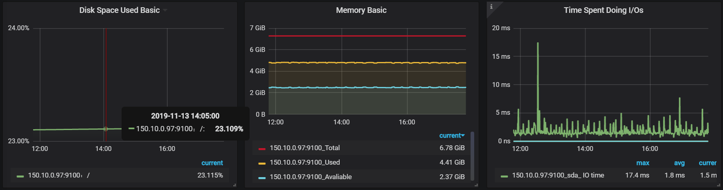

***aks-agentpool-32091406-2 (VM 3):***

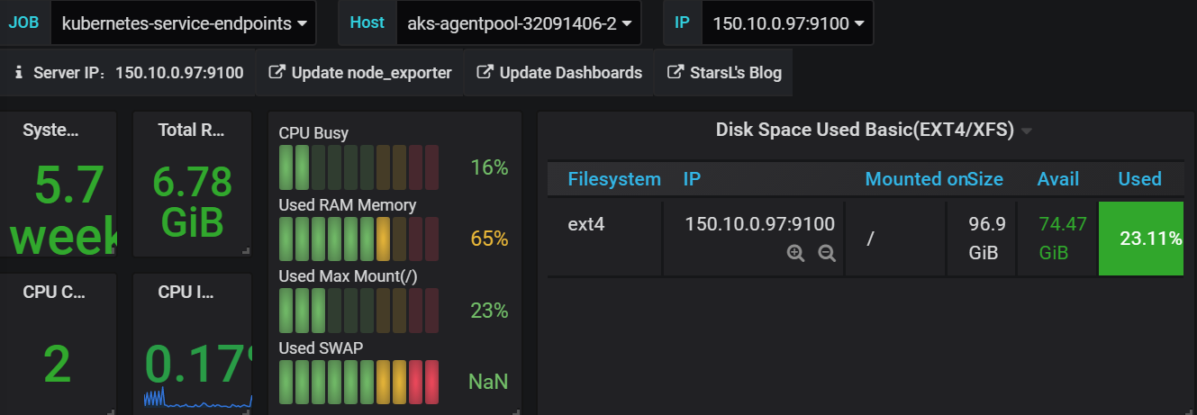

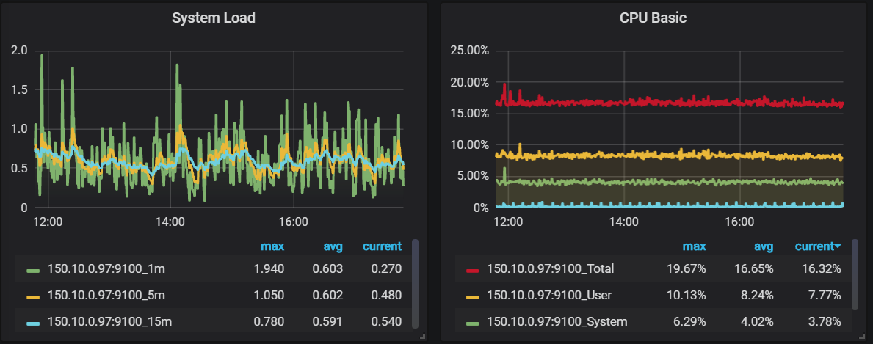

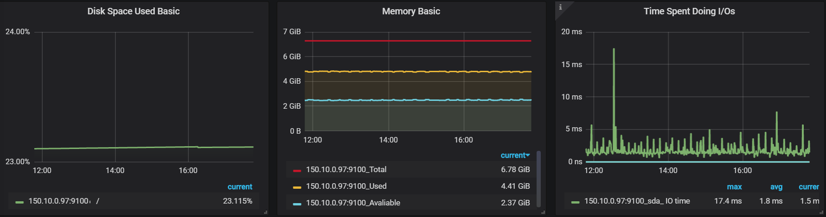

***aks-agentpool-32091406-3 (VM 4):***

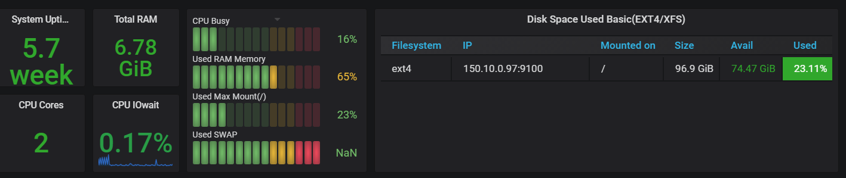

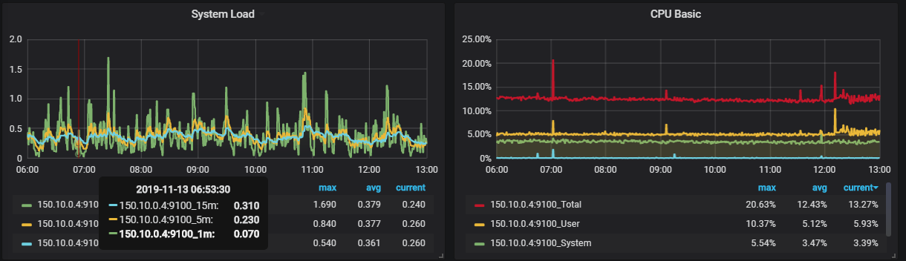

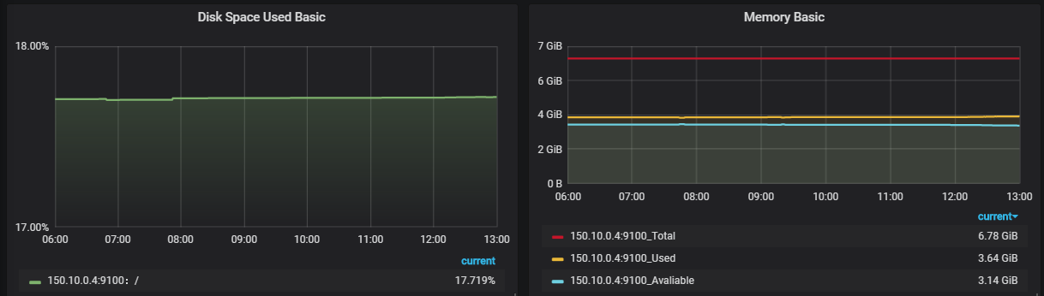

***aks-agentpool-32091406-4 (VM 5):***

